Задание 3

var s:String = "Hello world!"

var counter = 0

for i in s{

counter+=1

}

print(s.count)

print(counter)

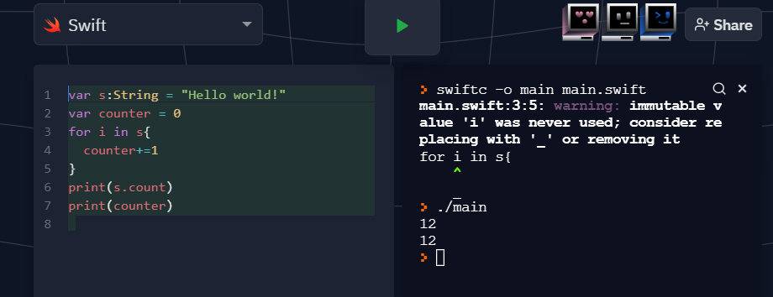

Задание 1

import Foundation

let s:String = "Hello Hello Hello Hello Hello World Hello!"

let sArr = s.components(separatedBy: " ")

var counter:Int = 0

var s1:String = "Hello"

for i in sArr{

if s1 == i{

counter+=1

}

}

print(counter)

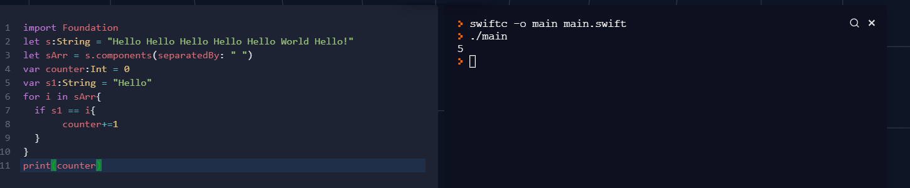

Задание 2

import Foundation

var s:String = "das29++23-25+s555d,.+-000+-dad234"

print(s)

var flag : Bool = true

var res = ""

var counter = 1

for item in s

{

if(item >= "0" && item <= "9" || counter != s.count && s[s.index(s.startIndex, offsetBy: counter)] != "-" && s[s.index(s.startIndex, offsetBy: counter)] != "+")

{

res.append(item)

}

counter += 1

}

print(res)

var s2 = ""

var k = 0

while k < res.count-1{

if (res[res.index(res.startIndex, offsetBy: k)] == "+"

|| res[res.index(res.startIndex, offsetBy: k)] == "-")

{

var j = k+1

while (res[res.index(res.startIndex, offsetBy: j)].isNumber){

s2.append(res[res.index(res.startIndex, offsetBy: j)])

j+=1

}

}

k+=1

}

print(s2)

